Attack of the Killer Bears

Data Analytics Boot Camp

Project 1

Team Members:

Geoffrey Holland

Karsten Olsen

Sarah Raisian

David Winton

**Overview**

People are told that bears are dangerous, but how often do bear attacks occur? Who are the primary victims? How do they die? Where (in North America) do they occur? Have these deaths declined over time? Curiosity on the statistics of fatal bear killings, the team used a dataset to find answers to some of these questions.

**Data**

The dataset used is from Data.World* called “north_america_bear_killings.csv” that consists of 167 victims and 14 features describing their death. The features include: Name, Age, Gender, Date, Year, Type(Wild or Captive), Location, Description, Type of Bear, Hunter (Boolean value), Grizzly (Boolean value), Hikers (Boolean value), Only One Killed (Boolean value).

There were 2 missing values of the Age feature – so for analyzing the victim exploration, the team dropped these values. In addition, there was the Grizzly Boolean feature that is a type of brown bear. Therefore, for analyzing the type of bear, Grizzly was included and should be understood as a subset of brown bear.

To analyze the data, the team used various packages in Python using Jupyter to cultivate visual findings to the questions listed above.

**Analysis**

Who Dies from Bear Killings?

How Do They Die?

The victims in the dataset were majority killed by brown bears including grizzly bears at 48.2%, slightly higher than black bears at 45.8%. Polar bears only accounted for 6% of the killings, mostly because populations are not as dense where the polar bears live. 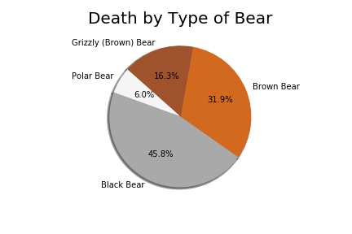

Not surprisingly, most bear killings occur in the wild (83.1%) as opposed to captive deaths (from “pet” bears or zoo captivity).

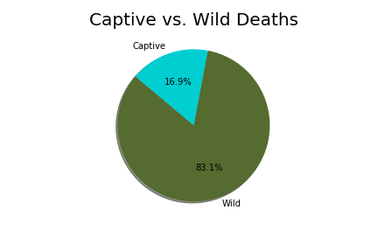

Most identified deaths were from people hunting, suggesting they were out seeking secluded area with other animals or even seeking out the bears. The “Other” category could be further identified using text mining techniques to seek further answers to what the victims were doing when they died.

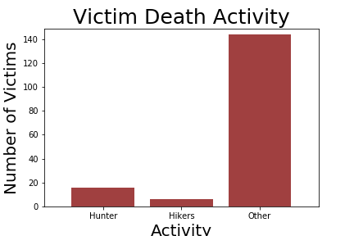

Have Killings Decreased Over Time?

Where Do They Occur?

Most of the bear killings recorded in the dataset were near Glacier National Park, Montana or Yellowstone National Park. The graphs below only record locations with 2 or more deaths to see recurring deaths. Most of these deaths occur north in Alaska or Canada, and could occur in National Parks because of the tourism attraction to areas where bears live.

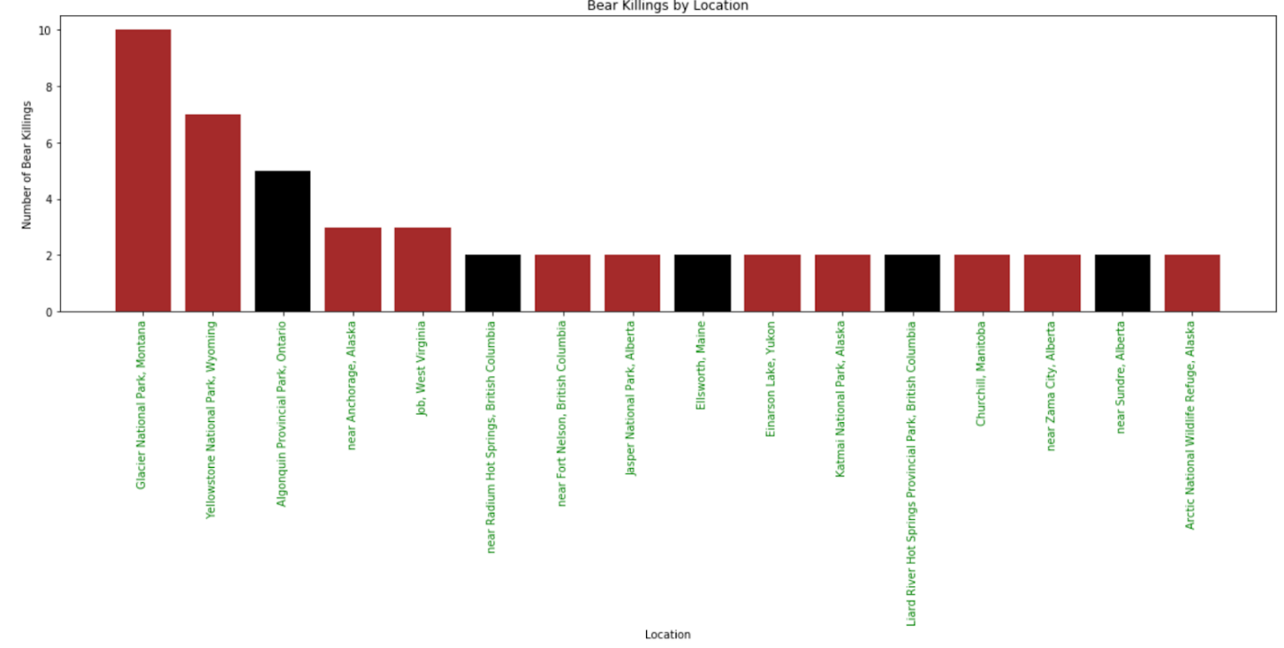

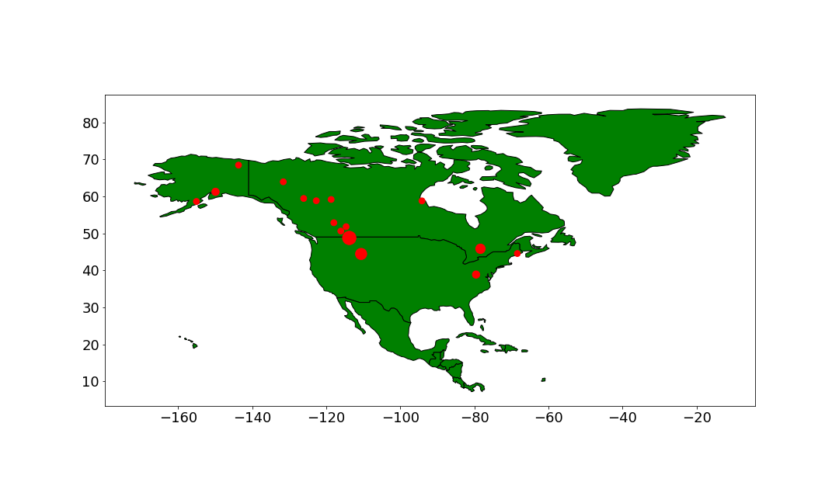  
Summary